BLENDED INTENSIVE PROGRAMME ERASMUS+  LGBTI* in European laws and beyond  LYON 2024 | 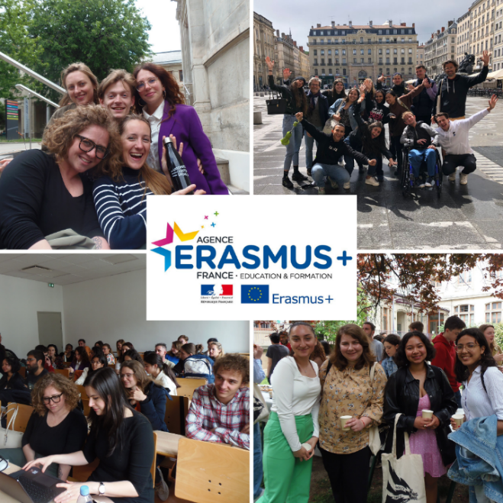

Blended Intensive Programmes Erasmus+ are hybrid programmes, consisting of an online part and an in-presence part. For this academic year, the week in attendance of the BIP LGBTI* in European laws and beyond will take place at the University Lumière Lyon 2 (France) from Monday 19 May to Friday 23 May 2024.
The dates of the in-person session are fixed as stated above.
The dates of the virtual session will be fixed in February.
The programme details presented below may be slightly modified.

OBJECTIVES
- Learning more on the protection of SOGIESC (sexual orientation, gender identity and expression and sex characteristic) in international and national laws in Europe, with a focus on the European convention of human rights and the relevant case law;
- Learning more on the conceptual and pragmatical issues related to SOGIESC;
- Learning more on the evolution of the laws regarding SOGIESC: the legal forces and tools pushing for changes and the one resisting;
- Learning more on the diversity of legal approaches and the importance of the cultural context, through the comparative studies of international and internal laws.

ONLINE PROGRAMME
Around one month before the program  1h evening session | Presentation of the program + methodological session on the expectation of the collective works later made by the students
Around 2 weeks before the program  2h evening session | Presentation by the students of each national context related to SOGIESC + Q&A session on these contexts

Regarding the collective work, which will be based on national cases law related to LGBTI* minorities, it will be prepared by group of 4 to 5 students. The case chosen by each group will have to be validated by the pedagogical team. Then each group of students will have to present the national context of the case and make a presentation on it.
Once this work will be done, each team will prepare its presentation with proper slides. The part of their work related to the context of the case, will be presented during the 2nd online meeting, whereas the legal commentary itself of the case will be presented during the in-person session.

LYON (campus Berges du Rhône – 4bis Rue de l'Université, 69007 Lyon)
Monday 19 – Friday 23 May 2024
IN-PRESENCE WEEK PROGRAMME
Monday 19th of May 2024  Inaugural lecture  &  Students’ presentation | 9h00 –  9h30 | Room TBA | Welcome breakfast - Registrations
 | 9h45 –  12h00 | Room TBA | Connecting the history of the international protection of women’s rights with the protection of “LGBTI+” rights  Marjolein van Den Brinks (Utrecht University)
 | 12h15 –  13h15 |  | Lunch
 | 13h30 –  17h00 | Room TBA | Presentation & discussion of the students’ collective work  Elena Mascarenhas & Benjamin Moron-Puech (ULL2)
Tuesday 20th  Body, Identity and family | 9h –  12 | Room TBA | 1/ A brief history of SOGIESC in international human rights law  2/ The protection of gender identity and “LGBTI+”’ body integrity in international human rights law  Benjamin Moron-Puech (ULL2)
 | 12h15 –  13h15 |  | Lunch
 | 13h30 –  16h00 | Room TBA | The right to respect for family life of “LGBTI+”  Peter Dunne (Bristol University)
 | 16h30 –  18h30 |  | Thematic guided tour of the city center of Lyon

Wednesday 21th  International laws and economy | 9h00 –  10h30 - | Room TBA | The protection against discrimination on the basis of SOGIESC  Marcin Górski (University of Lodz)
 | 10h45 –  12h15 | Room TBA | International economic treaties and their contribution to the protection of human Rights  Andreas Ziegler (University of Lausanne).
 | 12h15 –  13h15 |  | Lunch
 | 13h30 –  16h | Room TBA | T* vs the others oppressed groups?: discussing the raise of alleged conflicts between the rights of the trans & non-binary people on the one side and the LGB, religious minorities or women on the other side.  Elena Mascarenhas & Benjamin Moron-Puech (ULL2)
 | 17h00 –  19h00 | Amphithéâtre culturel (Bron) | Play by Theatre North, Martin Lewton, Billy Budd Sailor
Thursday 22th  Are strategic litigation really successful? | 9h00 – 10h30 | Room TBA | Asylum rights related to SOGIESC  Mariza Avgeri (Open university)
 | 10h45 – 12h15 | Room TBA | A conversation on the legal and philosophical foundation of LGBTIQ human rights  Damir Banovic (University of Sarajevo)
 | 12h30 –  14h00 | Restaurant Universitaire Les Quais | Lunch
 | 14h30 –  16h30 | BDR  CLI.036 | The future of SOGIESC? Reflecting on strategic development and a vision of equality without compromise  Silvain Agius (international expert on SOGIESC)

Friday 23th  Closing day | 10h00 –  11h00 |  | EXAM
 | 12h00 –  13h00 |  | Lunch
 | 13h30 –  16h30 | AMPHI LAPRADE  CLI.047 | Closing session with the participation of  - ECHR Judge for Czech Republic, Katerina Simackova  - French LGBT ambassador, Jean-Marc Berthon  - More to be announced

